
AI-DRIVEN SYSTEM FOR FASHION ANALYSIS FROM LAGOS FASHION WEEK F/W 2025 (HoL – HOUSE OF LASGIDI)
Anita Oghenerukevwe Dijala
[ID NUMBER]

Final Year Project
GHSCC.300
Department of Computer Science
Lancaster University Ghana

DECLARATION

I attest that the content of this dissertation report is my own. I certify that the content of this report has not been submitted anywhere else for any award. I also certify that the application’s implementation and research have not been submitted elsewhere for any award and are solely owned by me, Anita Dijala. I agree that this work be saved electronically for academic purposes. I do not give my consent for the work presented in this report, and any and all accompanying documentation which includes the system implementation, to be made public without ascertaining prior consent and permission from myself.

Table of Contents
Type chapter title (level 1) 1
Type chapter title (level 2) 2
Type chapter title (level 3) 3
Type chapter title (level 1) 4
Type chapter title (level 2) 5
Type chapter title (level 3) 6

ABSTRACT
In traditional fashion trend forecasting, there is a large reliance on manual observation and a lack of real-time, data-driven frameworks to quantify choices. Specifically, within the context of African fashion showcases like Lagos Fashion Week, there is a gap in utilizing computational systems to evaluate designer collections. The absence of these datasets makes it technically difficult to train algorithms or accurately replicate the unique physical textures of African fabrics in digital spaces (Boateng et al., 2025). Enforcing these data frameworks is essential for decision-makers who require reliable metrics to improve the production chain and establish sustainable infrastructure across the continent.
To address this, the project introduces ‘House of Lasgidi’ (Hol), an AI-driven computer vision and sentiment analysis system designed to evaluate the Lagos Fashion Week F/W 2025 show. For colour sentiment analysis, the system evaluates and compares two semantic segmentation pipelines, DeepLabV3+ and FashnHumanParser, followed by K-Means clustering. Fabric sentiment analysis is achieved by extracting visual features using the Gray Level Co-occurrence Matrix (GLCM) and Local Binary Patterns (LBP), which are classified using Support Vector Machine (SVM). The insights collated are aggregated into a dashboard for brand-specific analytics.
The system testing compared the colour segmentation pipelines, revealing that [DeepLabV3+/FashnHumanParser] achieved a superior accuracy of [INSERT %]. On the other hand, the GLCM-LBP-SVM pipeline successfully classified fabrics with [INSERT %] accuracy.
These results demonstrate that HoL provides a scalable, objective tool for designers, buyers, and forecasters to derive actionable, data-driven business insights from runway showcases, effectively bridging the knowledge system gap in African fashion.

INTRODUCTION
The necessity for such frameworks is supported by recent findings that for the African fashion industry to progress and thrive, individuals, like designers, buyers, and forecasters, in the fashion industry require more dependable data than is currently available (UNESCO, 2023). Existing industry data is largely incomplete, focusing mainly on raw textile production rather than the high-fashion sector or specific consumer design sentiments (UNSECO, 2023). This lack of analytical infrastructure emphasizes on wider challenges in the region, including a drawback in the infrastructure required to scale creative cooperations (UNESCO, 2023). Current fabric data in Africa is heavily fragmented and sparse. This data gap is observed by a critical lack of digital archives, as traditional textile knowledge is frequently preserved through oral traditions rather than machine-readable formats (Boateng et al., 2025).

3 DESIGN
3.1 Introduction
This chapter discusses the design of major components and details of the methods used for the House of Lasgidi (HoL) framework. Emphasizing on the limitations identified within the fashion data landscape in Nigeria, this design presented here focuses on an AI-driven pipeline capable of objective quantification. The design follows a modular architecture, separating the heavy computational tasks of garment segmentation and texture feature extraction from the user-based visualization dashboard. This approach was chosen to enable the comparative testing of colour pipelines while maintaining a seamless user experience for fashion professionals. Furthermore, this section illustrates the functional and non-functional requirements of the system.

3.2 Requirements Specification
The design of all systems follows a basic structure of two major requirements, namely, functional and non-functional requirements. Therefore, the system specification is broken down into two parts. The functional requirements of this system focus on immediate concerns as opposed to the non-functional requirements; therefore, this section of the report will give a detailed description and illustration of the functional and non-functional requirements for HoL.
3.2.1 Functional Requirements
3.2.2 Non-Functional Requirements
3.3 Use-Case Model
3.3.1 Actors
This system would have three main actors:
- User (Designers, Buyers, Students) – a person who views and filter analysed results.
3.3.2 Use-Case Diagram
DEFINITION OF USE CASE DIAGRAM

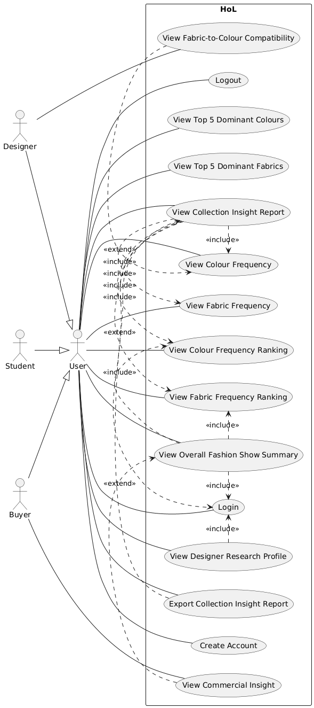
Figure 1: House of Lasgidi (HoL) Use Case Diagram
3.3.3 Use-Case Scenarios
Use Case | Use Case Description | Actor(s)
Select brand | The user chooses a specific brand’s collection to view its analysis | User, Admin
Select Trend Analysis | Allows the actor to choose the results of the colour analysis and the fabric analysis. | User
View Fabric Distribution | Displays the identified materials found on the runway, as well as a visualised graph of the top 5 dominant fabrics present. | User
Interpret Trend Insights | The dashboard view that summarises the brand’s entire collection based on the colour palette and the fabric. | User
View Colour Palette | Displays the top 5 dominant colours present in the brand’s collection in different visualised graphs. | User, Admin
Trigger Analysis Pipelines | Initiates the processing of the programming. | Admin

3.4 Architectural Design
3.4.1 Overall Architecture
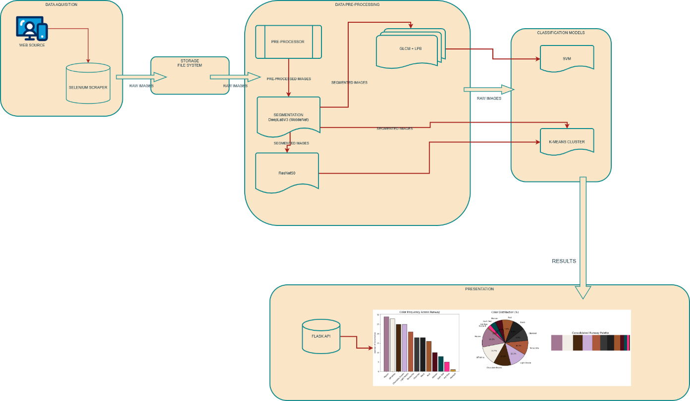
3.4.2 Data Flow Diagram
3.5 Module Decomposition
3.5.1 Image Pre-Processing & Segmentation Module (architecture diagram segment included, sequence diagram of that) Show the flow from the raw runway image to the segmented output…
3.5.2 Feature extraction module: Detail the attributes being sent to the GLCM and LBP functions.
3.5.3 classification and clustering module
3.5.4 visualisation module
3.6 UI/UX Design
3.6.1 Dashboard Layout & Navigation - Layout of dashboard images. Include low-fidelity wireframes of your dashboard. Show where the overview stats go and where the brand-specific analysis sits. And justify how the design is for the user.
3.7 Data Design. How data is structured and stored between the AI output and the Dashboard. How is the sentiment data stored? (e.g., JSON files, CSV, or an internal Python dictionary structure?). Examiners want to see how you organized the brand-specific results.
3.8 Design justification. Why SVM? Why K-Means? Why specific color spaces?
3.9 Constraints. Technical or time-based limitations
3.10 Conclusion

